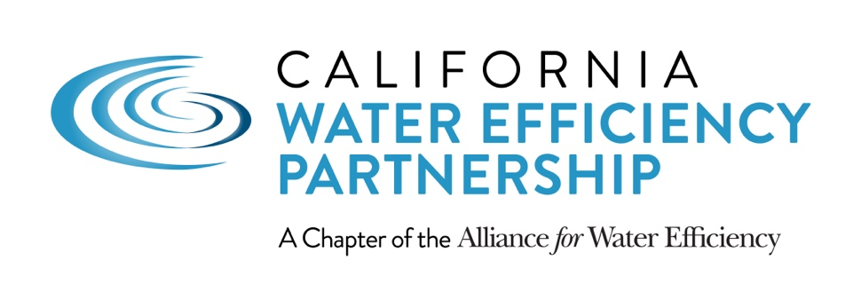

california’s new WATER EFFICIENCY laws

outreach and media toolkit

- Template Language for Community Outreach

- Talking Points for Agency Staff Including Customer Service Representatives

- Social Media Sample Posts and Sharable Images

AUGUST 2018

TEMPLATE LANGUAGE ON WATER CONSERVATION LAWS FOR COMMUNITY OUTREACH

New Laws Provide a Framework for Water Conservation

This year, Gov. Brown signed landmark legislation designed to guide the next generation of water conservation standards in the state. The overall goal is to make water conservation a way of life in California and a permanent part of the state’s culture in light of the state’s frequent cycles of drought.

Many details for implementing the new laws will be determined over the next several years, and there are no immediate impacts to customers. The laws provide a framework for water providers to set new, permanent water use targets by 2022 that combine:
- An indoor standard of 55 gallons per person per day
- An outdoor standard for residential and commercial customers based upon our local climate and the amount of landscaped area
- A standard for water loss from leaks in the water system

These standards will be calculated and added together to create one overall target for each water provider area. Individual customers will not be required by the state to meet specific targets.

Once targets are set, [insert your organization] will work to decide how to best meet the targets--through water-wise rebates, infrastructure improvements, outdoor watering guidelines and/or other efforts. In the meantime, [insert your organization] will continue to offer rebates and services to help customers use water wisely, including incentives to [insert rebates you offer… upgrade to more efficient toilets, clothes washers and irrigation equipment]. You can learn more at [insert your URL].

In California, droughts are a part of life, and the next dry year is always right around the corner. We look forward to continuing our partnership with our customers to implement these new laws and to make water efficiency a way of life no matter the weather.

TALKING POINTS ON CONSERVATION LAWS FOR AGENCY STAFF INCLUDING CUSTOMER SERVICE REPRESENTATIVES

Primary Talking Points

California recently passed two new laws that require water providers, including [insert your organization] to set new, permanent water use targets by the year 2022.
- There are no immediate impacts on customers.
- Many details for implementing the new laws will be worked out over the next several years.

The laws provide a framework for setting targets that include standards for the amount of water used indoors, the amount of water used outside (based on our local climate) and for water lost to leaks in our system.
- These standards will be rolled into one overall target for our service area
- Individual households and businesses will not be required to individually meet any standards

Once targets are set, we will decide how to best achieve the new targets as a service area.
- In the meantime, we are continuing to offer rebates and programs to help our customers use water wisely.
- These include [insert information about rebates and programs available].

Frequently Asked Questions

How will the new laws impact customers?
There are no immediate impacts to customers. Over the next several years, water use targets will be set for our overall service area (not on an individual basis) based upon the framework outlined in the laws. Once targets are established in 2022 and implementation begins in 2023, we may work with individual households and businesses to increase water efficiency through rebates, services, programs or other means.

Why were the new laws created?
The new laws were prompted by the state’s frequent cycles of drought. They are meant to better prepare California for the next drought and the future effects of climate change on the state’s water supplies. The overall goal is to make water conservation a way of life in California.

Will it be illegal to take a shower and wash clothes in the same day, as some media have reported?
No. There is nothing in the laws that specifies when or how often a person may shower or do laundry. The new laws provide an overall framework for setting and meeting water use targets at the water provider level. While the framework does include a goal for individual indoor water use of 55 gallons per person per day beginning in 2022, this applies on an overall system-wide basis (and not an individual basis) and will not be enforced on an individual basis.

How hard will it be to meet the indoor target of 55 gallons per person per day?
It’s important to know that the target of 55 gallons per person per day is not a state mandated goal for individual customers, but will be measured across our entire service area. That said… [Insert information about your service area. For example: In our service area, many of our customers are already meeting this target or do not have far to go.] To help customers reduce their indoor water use, we offer rebates for [insert information about your rebate programs such as… upgrading to high-efficiency toilets and clothes washers.]

Will you be monitoring and evaluating individual water use as part of the new laws?
The new laws do not require that individual households meet a specific target. The new laws provide a framework for setting targets on an overall basis for our entire water system, and we’ll be monitoring progress toward achieving targets on a system-wide basis.

Will individual households and businesses be fined for not meeting water use targets?
The new laws do not require that individual households or businesses meet a specific target. The new laws provide a framework for setting targets on an overall basis for our entire water system. That said, individuals and businesses may be fined for violating local water waste ordinances.

Will residents have to go back to saving water as they did during the drought?
No. The new laws create long-term water use targets not short-term, emergency conservation targets like those implemented during the drought. The long-term targets are meant to inspire greater efficiency over time rather than mandate short-term cutbacks that require extreme measures such as not watering your lawn or flushing the toilet less.

How will the new laws impact businesses in California?
The new laws do not set specific water use targets for business, but they do outline a framework for creating new water efficiency performance measures for businesses. These are recommended actions for specific business sectors to improve water efficiency over time. Performance measures will be determined over the next several years, and the process will include opportunities for public input.

When will the new water conservation targets take effect?
Water providers must set new water conservation targets by 2022 and will be expected to begin implementing them by 2023 and every year after that.

What are the next steps for implementing the new laws?
The laws will now be translated into regulations, which will outline details and rules for implementation at the local level. [Insert information about your organization’s participation. For example: We will be actively involved in working with other stakeholders and state agencies to help shape and finalize the regulations by the deadline of 2022.]

SOCIAL MEDIA SAMPLE POSTS AND SHARABLE IMAGES

Sample Social Media Post: Water Targets
Water providers are required by law to set new water use targets for their service areas by 2022. Targets will combine the items below into one overall goal for our area. You can learn more about the new conservation requirements and water-wise rebates at [insert your URL].
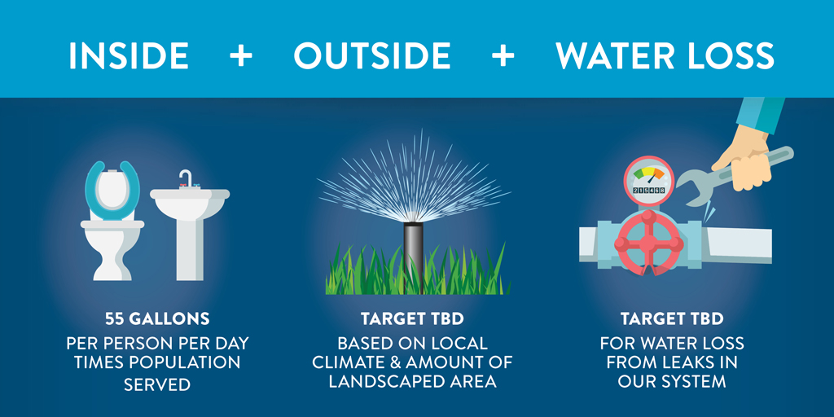

Sample Social Media Post: Indoor Water Use
New laws require water providers to set new water use targets for their service areas by 2022. While the new laws set a starting indoor target of 55 gallons per person per day, this goal is not for individual customers but will be multiplied by the total number of people we serve and measured across our entire area. You can learn more about the new conservation requirements and water-wise rebates at [insert your URL].
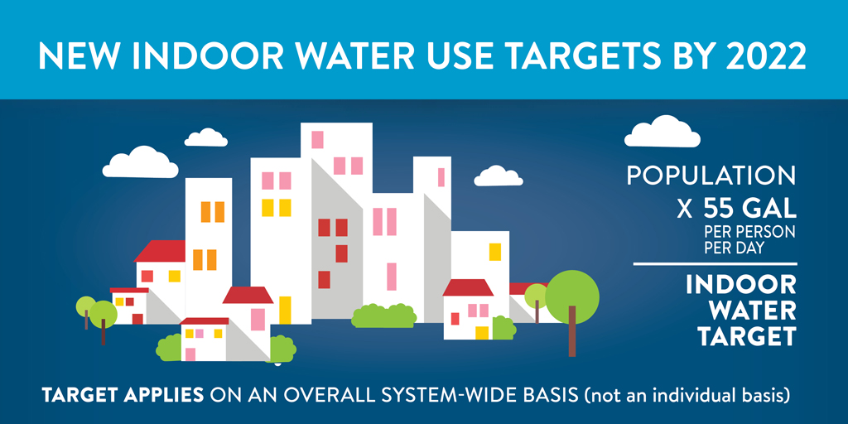

SOCIAL MEDIA POSTS CONTINUED…IMAGES COMING SOON.

Sample Social Media Post: Outdoor Water Use
Much of the water we use daily goes toward watering lawns and landscaping. That’s why new conservation laws require water providers throughout California including [insert your organization] to set new targets for outdoor water use. Targets (TBD in the coming years) will be based upon our local climate and the amount of area that can potentially be irrigated. Visit [insert your URL] to learn more about the state’s new conservation laws and rebates available to help you use water wisely.

Supporting image coming soon

Sample Social Media Post: Water Loss
Addressing water lost to leaks in underground pipes is an important part of the state’s new conservation laws. Statewide, it’s estimated that about 10 percent of the water that flows through pipes underground is lost to leaks. At [insert your organization], we work diligently to find and quickly fix leaks in our system and expect to be increasing these efforts even more. You can learn more about the new conservation laws and water-wise rebates at [insert your URL].

Supporting image coming soon

Sample Social Media Post: Timing
Change takes time. The new water conservation laws will take effect incrementally over the next few years. [Insert how your agency will be engaging in the process.] Stay tuned for more updates. Visit [insert URL here] to learn more about the new conservation laws and water-wise rebates.

Supporting image coming soon

