How to Get to the UC Davis Conference Center

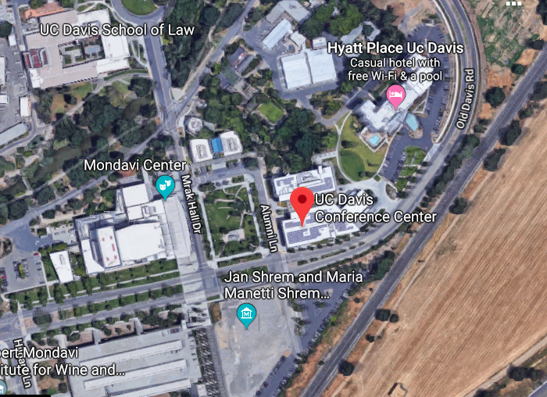

Driving Directions

From I-80 West (San Francisco)
- Take I-80 East toward Sacramento.
- Exit the UC Davis exit #71 (just after the HWY 113 interchange).
- Turn left at the stop sign onto Old Davis Road.
- Continue straight past the information booth.
- Turn right onto Hilgard Lane (immediately after the Mondavi Food and Wine Institute buildings) and park in either the structure or the parking lot.
- The Conference Center is East of the Vanderhoef Quad from the Mondavi Performing Arts Center at the corner of Old Davis Road and Alumni Lane.
- The entrance is to the left of the glass corner of the building.

From I-80 East (Sacramento)
- Take I-80 West toward San Francisco.
- Exit the UC Davis exit #71 (after the Richards Blvd exit)
- Turn right at the stop sign onto Old Davis Road.
- Continue straight past the information booth.
- Turn right onto Hilgard Lane (immediately after the Mondavi Food and Wine Institute buildings) and park in either the structure or the parking lot.
- The Conference Center is East of Vanderhoef Quad from the Mondavi Performing Arts Center at the corner of Old Davis Road and Alumni Lane.
- The entrance is to the left of the glass corner of the building.

From I-5 North (Redding/ Woodland):
- Take I-5 South toward Sacramento.
- Take the HWY 113 South interchange to Davis.
- Take the I-80 East interchange to Sacramento.
- Exit the UC Davis exit #71 on the interchange
- Turn left at the stop sign onto Old Davis Road.
- Continue straight past the information booth.
- Turn right onto Hilgard Lane (immediately after the Mondavi Food and Wine Institute buildings) and park in either the structure or the parking lot.
- The Conference Center is East of Vanderhoef Quad from the Mondavi Performing Arts Center at the corner of Old Davis Road and Alumni Lane.
- The entrance is to the left of the glass corner of the building.

From Downtown Davis:
- Take First Street west toward campus and away from downtown.
- Turn left at Old Davis Road.
- Continue pass the Hyatt and through the first light
- Turn left onto Hilgard Lane (immediately after the parking structure) and park in either the structure or the parking lot.
- The Conference Center is East of Vanderhoef Quad from the Mondavi Performing Arts Center at the corner of Old Davis Road and Alumni Lane.
- The entrance is to the left of the glass corner of the building.

Parking
Please feel free to park in the South Entry Parking Structure, Lot VP 1 or Lot VP 2. Parking is $9, except for a few coin operated metered spots ($.25 for ten minutes). Weekday enforcement hours are 7 a.m.–10 p.m, Monday–Friday.
Parking costs $9 per day, Monday through Friday. Permits may be purchased from the dispensers in the parking lots. The machines will accept quarters, $1 bills, $5 bills, Visa or MasterCard credit cards.

